**User Instruction of Context Detection Application**

1. Installation and requirement

* Apk download: <https://github.com/Zidane-Han/Context-Detection-APP/releases>
* Operating system: Android 8.0 or higher
* The smartphone GNSS module should be able to receive GPS and GLONASS satellites.
* Please allow the application to access location information when opening the app for the first time.

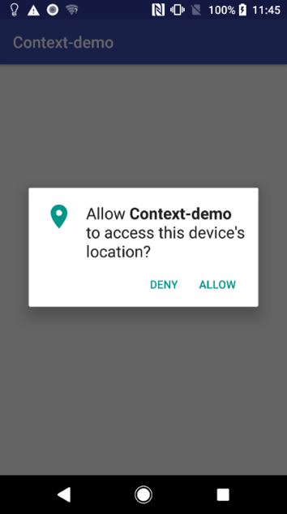

1. Activity tracking

* To start activity tracking, press the button “TRACK ACTIVITY” on the activity page.
* The recognised user activities are provided via Google Activity Recognition API. There might be some detection time delays (about several seconds) after transiting to a new activity. For details, please refer to following introduction.

https://developers.google.com/location-context/activity-recognition/

1. Environment detection

* Please turn on Location module in Settings to enable satellite tracking.
* The environment page provides environment detection results (indoor, outdoor or intermediate) and real-time display of satellite C/N0 values.
* Details about the environment detection algorithms, please refer to the following publications.

- Gao, H; Groves, D; (2018) Environmental Context Detection for Adaptive Navigation using GNSS Measurements from a Smartphone. Navigation , 65 (1) pp. 99-116.

1. Source code

The code source is maintained on GitHub (https://github.com/Zidane-Han/Context- Detection-APP), under the Apache License. The apk file for installation and user instruction can also be found on the above GitHub link. The project is built on Android Studio. Welcome to any improvement suggestion or pull request.